|  |  |  |  |
| --- | --- | --- | --- |
|  | Bansilal Ramnath Agarwal Charitable Trust's  Vishwakarma Institute of Information Technology  **Department of**  **Artificial Intelligence and Data Science** | | |
| Name: Kalpak Nemade | | | |
| Class: TY | Division: A | | Roll No: 371070 |
| Semester: V | | Academic Year:2022-2023 | |
| Subject Name & Code: Cloud Computing and Analytics | | | |
| Title of Assignment: Study of Cloud Computing & Architecture. | | | |
| Date of Performance: 22/08/2022 | | Date of Submission: 22/08/2022 | |

Aim: To explore different fields of AWS cloud such as Cloud Architecture and Cloud Services Provided by AWS cloud.

Problem Statement: Study of Cloud Computing & Architecture. Background Information:

1. Cloud Architecture: Cloud Computing architecture comprises of many cloud components, which are loosely coupled. We can broadly divide the cloud architecture into two parts: Front End & Back End. Each of the ends is connected through a network, usually Internet. The following diagram shows the graphical view of cloud computing architecture:

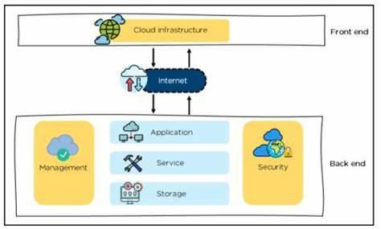

* + The **front end** refers to the client part of cloud computing system. It consists of interfaces and applications that are required to access the cloud computing platforms, Example - Web Browser.
  + It is the responsibility of the back end to provide built-in security mechanism, traffic control and protocols.
  + The server employs certain protocols known as middleware, which help the connected devices to communicate with each other.

1. Resource Components:
   * IAM - IAM is a cloud service that controls the permissions and access for users and cloud resources. IAM policies are sets of permission policies that can be attached to either users or cloud resources to authorize what they access and what they can do with it.
   * EC2 - Amazon Elastic Compute Cloud (Amazon EC2) provides scalable computing capacity in the Amazon Web Services (AWS) Cloud. Using Amazon EC2 eliminates your need to invest in hardware up front, so you can develop and deploy applications faster.
   * VPN - A cloud virtual private network (cloud VPN) is a form of technology designed to help users access their organization's applications, data, and files through a website or an application. Unlike traditional or static VPNs, a cloud VPN provides a secure connection that can be rapidly deployed globally.
2. Billing Information:
   * The AWS Billing console allows you to easily understand your AWS spending, view and pay invoices, manage billing preferences and tax settings, and access additional Cloud Financial Management services.
   * Quickly evaluate whether your monthly spend is in line with prior periods, forecast, or budget, and investigate and take corrective actions in a timely manner.

Cloud Resource Requirements: AWS Console Root Login Steps:

1.] Visit https://aws.amazon.com/premiumsupport/knowledge-center/sign-in-console/ . 2.] Click on Create new account on top right corner. This page will pop-up:

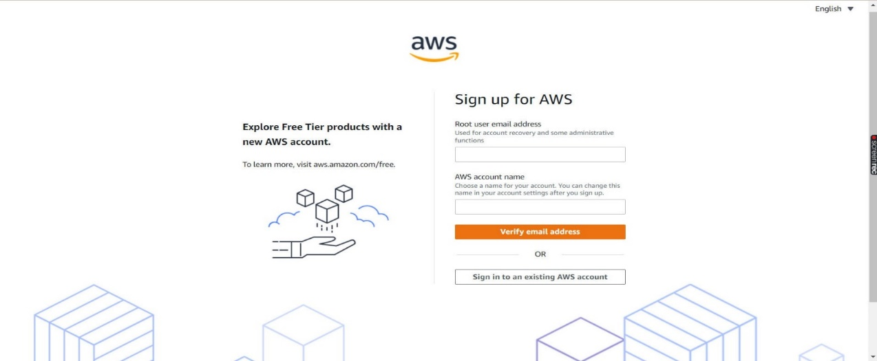

1. .] Enter your details & verify your email address.
2. .] Set your password & then required details. After completion comes payment page:

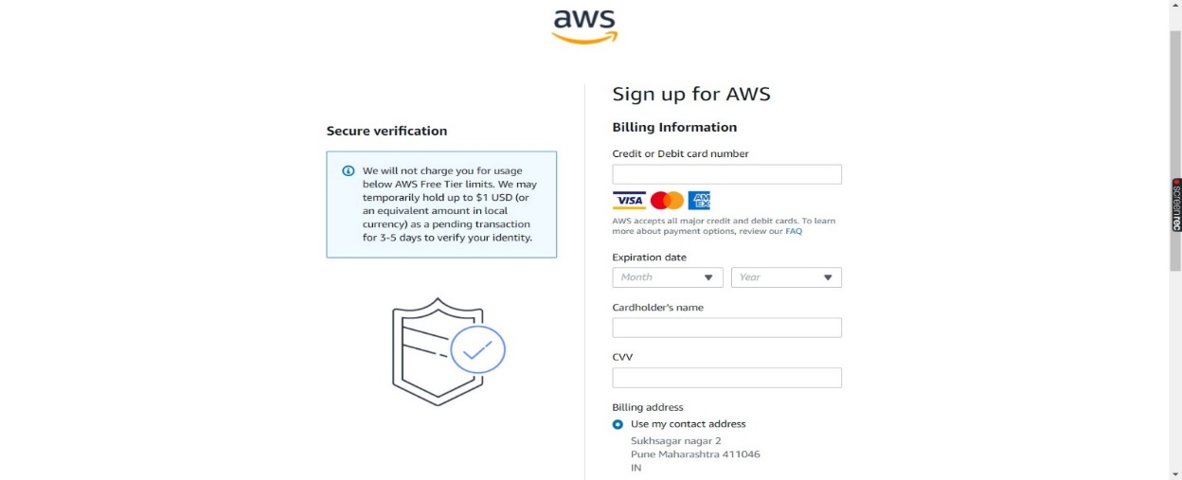

GitHub Repo Link:

https://github.com/mrkalpak/CCA-Assignemnt/

Conclusion: It is one of the demanding technologies of the current time and which is giving a new shape to every organization by providing on demand virtualized services/resources. It has many benefits like reduces IT costs, provide high security, etc.